EXPERIMENT 3

Jai Prasadh

PHY 115L

INTRODUCTION

In this experiment I sought to learn about vibrations of a cantilever. I first explored the free oscillations of the cantilever and calculated the natural frequency, decay rate, and quality factor of the device. I then focused on the cantilever’s driven oscillations when paired with an alternating induced magnetic field. Using the observations on the vibrations, I determined the amplitude of oscillation’s functional dependence on drive frequency and used the fitted function to determine again the natural frequency and decay rate of the oscillator. I used these estimated parameters to produce the graph of amplitude and phase lag versus drive frequency for the cantilever.

RESULTS

Free Oscillations of a Cantilever:

I studied cantilever # 13. I set off a freely decaying oscillation of the cantilever with some initial displacement but no initial velocity. As the cantilever vibrated, I recorded data for laser light intensity received by the detector as a function of time. Using this data, I fitted the damped harmonic equation which described the free oscillator’s motion to experimentally determine values for the natural frequency and the decay constant. Please refer to figure 1 below.

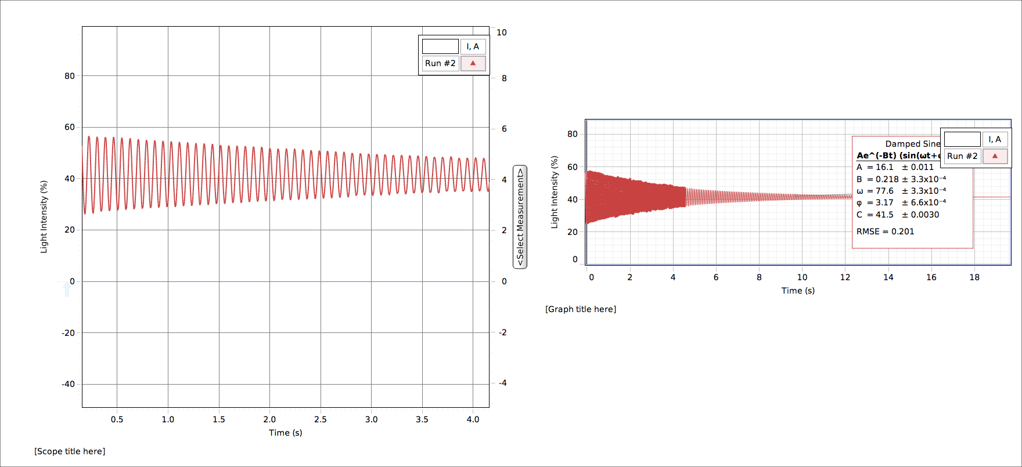

Figure

I determined the value of the resonant frequency to be $77.6±.1 Rad/s$ and the decay rate γ to be $0.436 ± .001 Hz$. From these fitted parameters, I calculated the quality factor of the cantilever as $178.0 ±0.5$. I report the standard errors in these values as greater than what the fits indicate because the fits underreport the uncertainty associated with irregularities in the oscillation I excited being collected by the detection system.

Driven Oscillations of a Cantilever:

In this portion, I drove the cantilever at various AC frequencies while recording the functions of voltage and light sensor intensity over time. Figures 2 and 3 depict two out of the many frequencies I drove the oscillator at, at low frequency and at frequency near resonance, respectively.

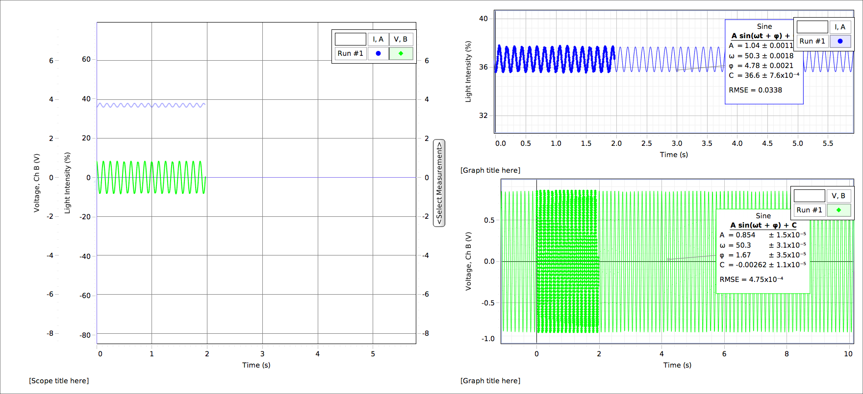

Figure

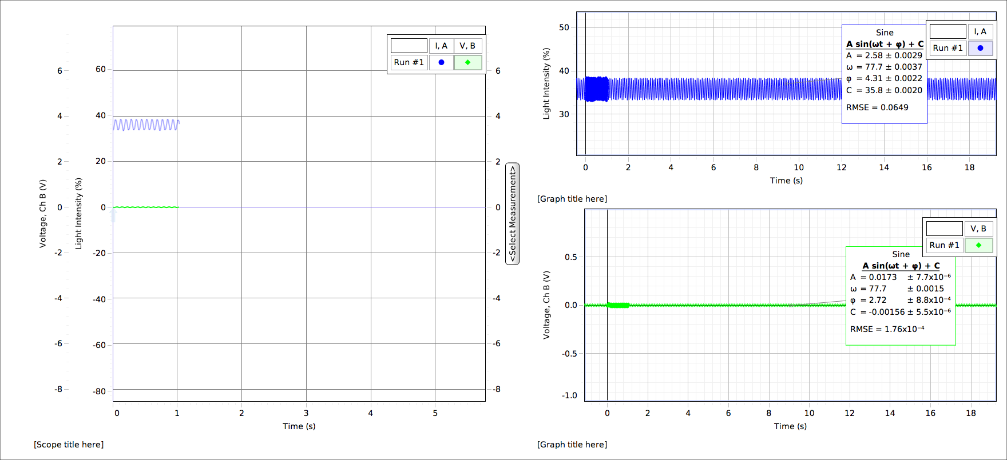

Figure

I would use the ratio of the fitted amplitudes of the voltage and light sensor signals to determine the shape of the function of amplitude ratio on drive frequency. I also recorded the difference in phase between the voltage signal and the light sensor signal at each frequency I collected data at. I plotted these data over a plot using the fitted values and the known functional dependence of phase angle on drive frequency to see how the observed values compared to the fitted values. Figure 4 illustrates the amplitude function while figure 5 shows a closer view of the peak of that function.

$$\begin{matrix}Parameter & Estimate & Standard Error & & \\ a & 5000 & 30 & & \\ b & -77.658 & 0.005 & & \\ c & -0.414 & 0.004 & & \end{matrix}$$

$$\frac{a}{{\left[{\left(w^{2}-b^{2}\right)}^{2}+w^{2}c^{2}\right]}^{1/2}}$$

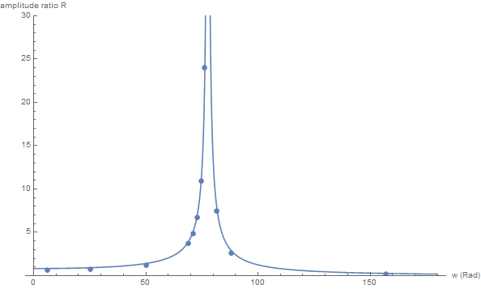

Figure

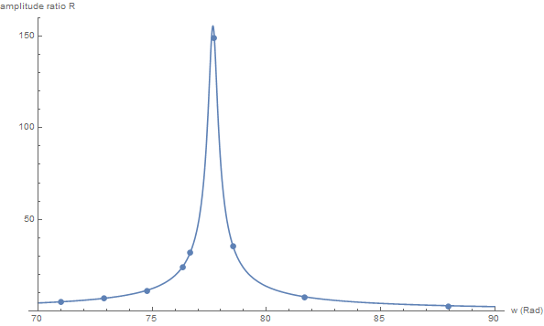

Figure

Figures 6 and 7 similarly show the function of phase angle φ over time in both a holistic and near-resonance close-up view. The points are the observed phase angles while the curve is the theoretical relation using the fitted parameters from the amplitude fit.

$$\begin{matrix}Parameter & Estimate & Standard Error & & \\ b & -77.658 & 0.005 & & \\ c & -0.414 & 0.004 & & \\ & & & & \end{matrix}$$

$$arctan[cw/{(b^{2}-w^{2}})]$$

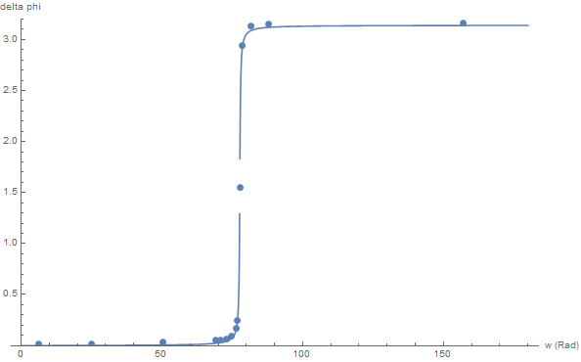

Figure

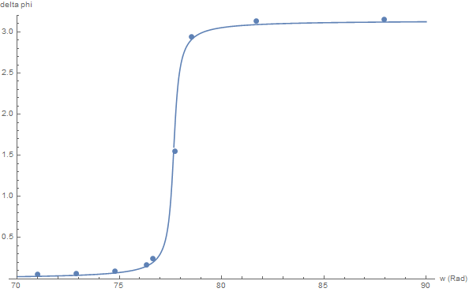

Figure

From this fitting these functions to the observations, I determined the natural frequency to be $77.658 ±.005 rad/s$ and the decay constant to be $0.414±.004 Hz$. Similarly, I calculated the quality factor from the fitted values as $188 ±2.$ This value of the resonant frequency matches the value previously calculated from the free oscillation while these values for the decay rate and the quality factor are very close to but outside the error bounds of the values from the free oscillation. The reason for this is more than likely the errors on the fitted values from the driven oscillation were understated. These error values were directly reported from the nonlinear model in Mathematica while there are probably other sources of error in the apparatus itself.

SUMMARY

My results for the freely decaying and driven oscillations largely confirmed the theory behind this type of motion of the cantilever (# 13). My values for the resonant frequency and decay rate agreed with each other between the free oscillation and driven sections. Also, the value of Q I calculated from the free decay was very close to that observed from the linewidth of the Lorentzian function. In my plots of amplitude ratio and phase difference versus drive frequency, the characteristic Lorentzian line shape and the inverse tangent were apparent in the fitted curves. The oscillator indeed lagged the drive by π/2 radians at resonance, where the amplitude ratio became extremely high (~149). As evidenced by the points superimposed on the curves, the experimental data lay closely along the curve without significant deviations away from it. The reason the fit and predicted parameter values weren’t perfect can be attributed to limits on the precision of my apparatus set-up, since small misalignments of the sensing system and oscillator could result in this small error.